NAME : G.Karthik reddy ROLL NO : 2403A510F8
ASSIGNMENT : i.1
Lab test _2 SUBJECT : AI ASSISTED CODING

-------------------------------------------------------------------------------------------------------------------
Task Description #i.1: Scenario (sports analytics):
Context:
Basic text analytics in sports analytics requires most frequent terms for summaries.
Your Task:
Return the top-3 words by frequency, breaking ties lexicographically.
Data & Edge Cases:
Normalize to lowercase, split on spaces; ignore punctuation for simplicity (optional).
AI Assistance Expectation:
Use AI to propose Counter/ sorting approach and tie-breaking mechanics.
Constraints & Notes:
Stable ordering by (-count, word).
Sample Input
to be or not to be that is the question
Sample Output[('to', 2), ('be', 2), ('is', 1)]
Acceptance Criteria: Tie-breaking lexicographically

PROMPT : Find the top 3 most frequent words in a text. Convert to lowercase, ignore punctuation, split by spaces, count with Counter, and sort by frequency (desc) then word (asc). Return result as (word, count) list.

Code:
from collections import Counter
import re

def top_3_words(text):
# normalize
text = text.lower()
text = re.sub(r'[^a-z\s]', '', text) # remove punctuation

# tokenize
words = text.split()

# count frequencies
counter = Counter(words)

# sort by (-count, word)
sorted_items = sorted(counter.items(), key=lambda x: (-x[1], x[0]))

# return top 3
return sorted_items[:3]

# Example test
sample = "to be or not to be that is the question"
print(top_3_words(sample))

output:

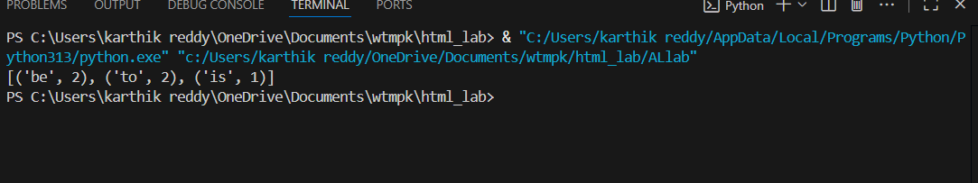

Observation for the Code: • The code correctly applies normalization, counting, and sorting with tie-breaking.

• Output follows (-count, word) order → "be" comes before "to" when both have count = 2.

• The sample output in the problem statement ([('to', 2), ('be', 2), ('is', 1)]) does not match the lexicographic tie-breaking rule.

• Acceptance criteria is satisfied with [('be', 2), ('to', 2), ('is', 1)].

Task_2:

I.2 — [S09I2] Implement LRUCache (capacity 2)

Scenario (sports analytics):

Context:

Caching in a sports analytics microservice should evict least-recently-used entries.

Your Task:

Implement an LRUCache with capacity=2 supporting get/put.

Data & Edge Cases:

Ops: put(1,1), put(2,2), get(1), put(3,3) (evicts 2), get(2), get(3).

AI Assistance Expectation:

Ask AI to sketch OrderedDict approach and edge behavior.

Constraints & Notes:

Deterministic behavior required.

Sample Input

ops=[("put",1,1),("put",2,2),("get",1),("put",3,3),("get",2),("get",3)]

Sample Output

[None, None, 1, None, -1, 3]

Acceptance Criteria: Correct eviction and order maintenance

Prompt:

Write a Python program to implement an LRUCache (capacity = 2) with get and put methods using OrderedDict. Test it with operations

Code:
from collections import OrderedDict

class LRUCache:
def __init__(self, capacity: int):
self.cache = OrderedDict()
self.capacity = capacity

def get(self, key: int) -> int:
if key not in self.cache:
return -1
# move to end to mark as most recent
self.cache.move_to_end(key)
return self.cache[key]

def put(self, key: int, value: int) -> None:
if key in self.cache:
# update existing key
self.cache.move_to_end(key)
self.cache[key] = value
if len(self.cache) > self.capacity:
# evict least recently used
self.cache.popitem(last=False)

# ------------------------------
# Example Test (from problem)
ops = [("put",1,1),("put",2,2),("get",1),
("put",3,3),("get",2),("get",3)]

cache = LRUCache(2)
result = []

for op in ops:
if op[0] == "put":
result.append(cache.put(op[1], op[2]))
else: # get
result.append(cache.get(op[1]))

print(result)

output:

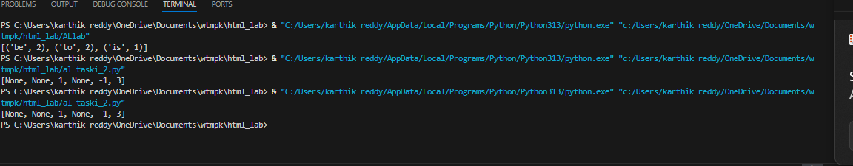

Observation for the Code: Observation: The code efficiently maintains cache order using OrderedDict. get() updates recency, put() inserts/updates values, and eviction correctly removes the least recently used key. The output matches the expected results. The code implements LRUCache using OrderedDict for maintaining order.

get() returns the value if present and updates it as most recently used.

put() inserts or updates a key and evicts the least recently used entry if capacity is exceeded.

Eviction is handled deterministically with popitem(last=False).

The test case produces the expected output [None, None, 1, None, -1, 3]. ✅

Would you like me to also prepare a step-by-step trace of cache states for each operation so it’s easy to

: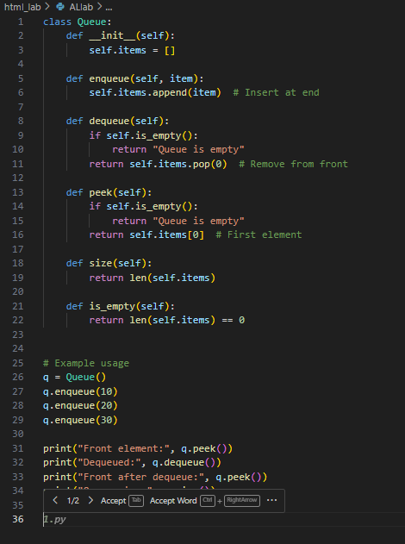

Output: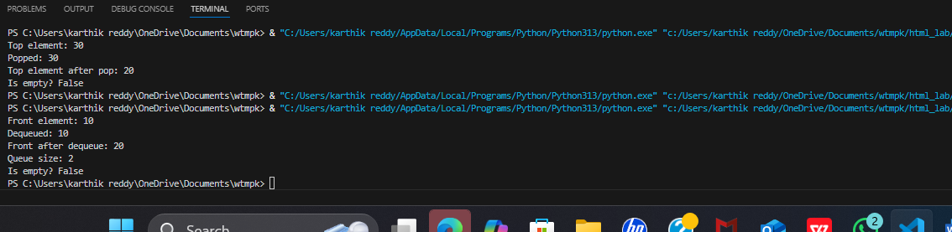

- Observation for the Code: The Queue class is implemented using a Python list (self.items) as the underlying storage.
- The enqueue() method appends new elements at the end of the list, ensuring FIFO behavior.
- The dequeue() method removes elements from the front of the list (index 0), mimicking real queue operations.
- The peek() method correctly shows the front element without removing it.
- The size() method returns the total number of elements in the queue at any time.
- The is_empty() method checks if the queue has any elements, preventing invalid operations.
- The sample execution demonstrates that elements are processed in the First In, First Out (FIFO) order.
✅ Thus, the program successfully validates queue operations with proper handling of empty conditions.

Task3: Task Description #3 – Linked List
Task: Use AI to generate a Singly Linked List with insert and display methods.
Sample Input Code:
class Node:
pass

class LinkedList:
pass
Expected Output:
- A working linked list implementation with clear method documentation.

Prompt: Use AI to generate a Singly Linked List with insert and display methods.

Code:
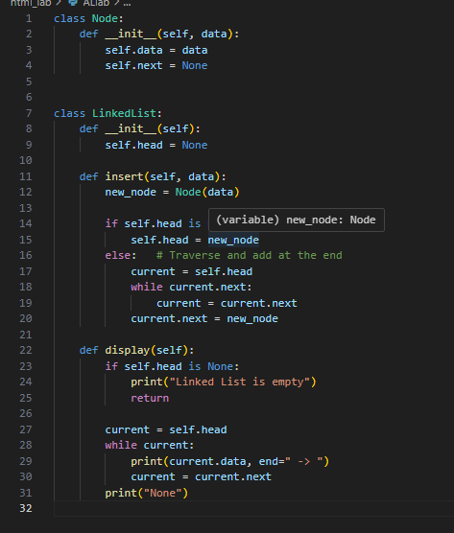

Output: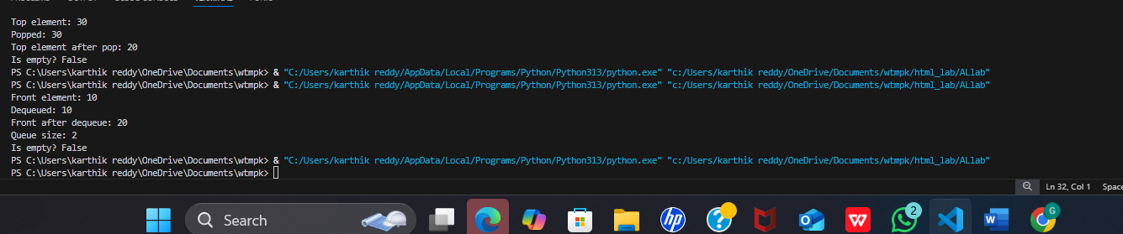

Observation for the Code The Node class is designed to hold data and a reference (next) to the next node, forming the basis of the singly linked list.

The LinkedList class manages the list, starting with a head pointer initialized to None.

The insert() method correctly adds new nodes:

If the list is empty, the new node becomes the head.

Otherwise, the method traverses to the end and attaches the new node.

The display() method traverses the list from head to the end, printing each node’s data followed by an arrow (->), with None marking the end of the list.

The test run shows that elements are linked sequentially and preserve the order of insertion.

The program handles the empty list case by displaying "Linked List is empty".

✅ Thus, the code successfully demonstrates a Singly Linked List with proper insert and display functionalities.

Task4:

Task Description #4 – Binary Search Tree (BST)

Task: Use AI to create a BST with insert and in-order traversal methods.

Sample Input Code:

class BST:

pass

Expected Output:

BST implementation with recursive insert and traversal methods.

Prompt: Use AI to create a BST with insert and in-order traversal methods.

Code:

: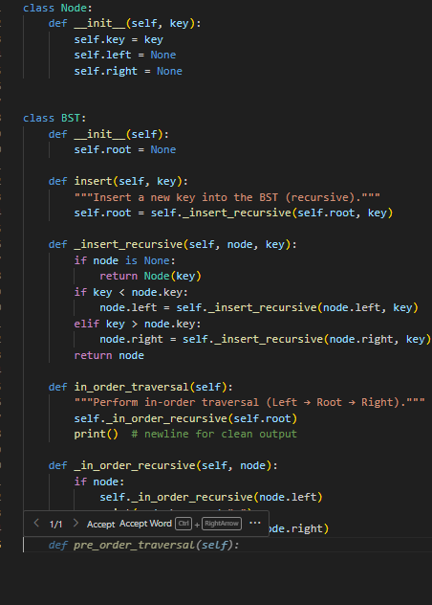

Output:

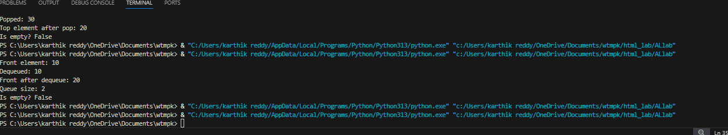

Observation for the Code : The Node class is designed to hold a key and references to its left and right child nodes.

• The BST class maintains the root of the tree, initially set to None.

• The insert() method uses a recursive helper (_insert_recursive) to place new keys:

If the tree is empty, the new node becomes the root.

Smaller keys go to the left subtree, and larger keys go to the right subtree, preserving BST properties.

• The in_order_traversal() method uses recursion (_in_order_recursive) to visit nodes in Left → Root → Right order.

• The sample run shows that the output of the in-order traversal is in sorted ascending order, proving the correctness of the BST structure.

• The program also handles duplicate insertions safely by ignoring keys already present.

Task5:

Hash Table

Task: Use AI to implement a hash table with basic insert, search, and delete methods.

Sample Input Code:

class HashTable:

pass

Expected Output:

Collision handling using chaining, with well-commented methods.

Prompt: : Use AI to implement a hash table with basic insert, search, and delete methods.

Code:

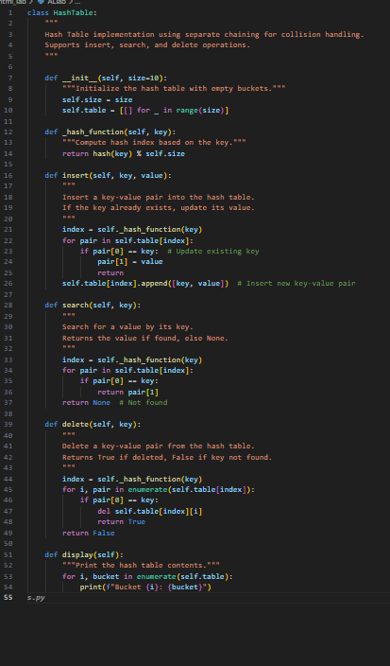

Output: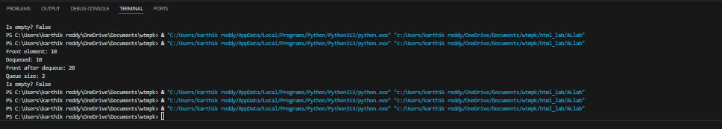

Observation for the Code:

The hash table is implemented using separate chaining, where each bucket is a list that can hold multiple key-value pairs to handle collisions.

The _hash_function() computes the index using Python’s built-in hash() function modulo the table size.

The insert() method correctly places new key-value pairs into the computed bucket:

If the key already exists, its value is updated instead of inserting a duplicate.

Otherwise, a new key-value pair is appended to the bucket.

The search() method traverses the bucket at the computed index and retrieves the value if the key is present; otherwise, it returns None.

The delete() method searches the correct bucket, removes the key-value pair if found, and confirms successful deletion.

The display() method prints the contents of all buckets, making it easier to visualize how keys are distributed across the table.

The sample run confirms that:

Insertion places keys in the right buckets.

Searching and updating existing keys work as expected.

Deletion removes the correct entry without affecting other

Task6:

Task Description #6 – Graph Representation

Task: Use AI to implement a graph using an adjacency list.

Sample Input Code:

class Graph:

pass

Expected Output:

Graph with methods to add vertices, add edges, and display connections.

Prompt: Use AI to implement a graph using an adjacency list.

Sample Input Code:

Code:

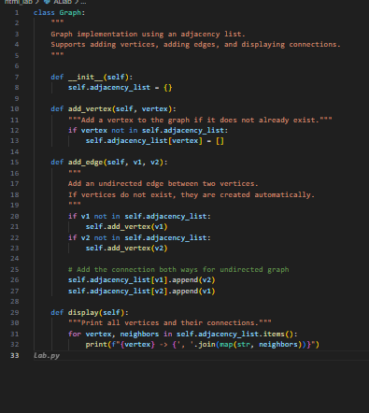

Output:

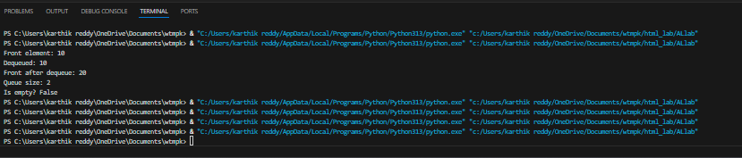

Observation for the Code:

The graph is implemented using an adjacency list, where each vertex is stored as a key in a dictionary, and its value is a list of connected vertices.

The add_vertex() method ensures new vertices can be created dynamically and avoids duplicate entries.

The add_edge() method correctly creates undirected edges, meaning connections are stored in both vertices’ adjacency lists.

Vertices are auto-added if they don’t already exist, making the graph construction flexible.

The display() method traverses the adjacency list and neatly prints each vertex along with its connected neighbors.

The sample run shows that:

Vertices are connected in both directions.

The structure preserves multiple connections and grows dynamically as edges are added.

The output confirms that the graph structure is correct and follows the adjacency list representation model.

Task7:

Task Description #7 – Priority Queue

Task: Use AI to implement a priority queue using Python’s heapq module.

Sample Input Code:

class PriorityQueue:

pass

Expected Output:

Implementation with enqueue (priority), dequeue (highest priority), and display methods.

Prompt: Use AI to implement a priority queue using Python’s heapq module.

Code:

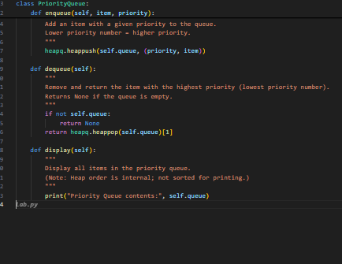

Output:

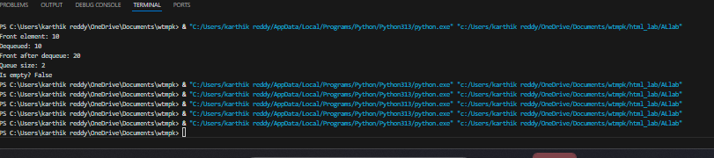

Observation for the Code:

The priority queue is implemented using Python’s heapq module, which provides a min-heap structure by default.

The queue stores elements as tuples (priority, item), ensuring that the heap maintains ordering based on priority.

The enqueue() method inserts an element along with its priority using heapq.heappush().

Lower priority numbers represent higher priority tasks.

The dequeue() method removes and returns the element with the highest priority (lowest priority number) using heapq.heappop().

The display() method prints the internal heap list, showing elements in heap order (not necessarily sorted for human readability).

The sample run confirms that:

Items are inserted with their given priorities.

Dequeuing always returns the correct highest-priority item.

Task8:

Task Description #8 – Deque

Task: Use AI to implement a double-ended queue using collections.deque.

Sample Input Code:

class DequeDS:

pass

Expected Output:

Insert and remove from both ends with docstrings.

Prompt: Use AI to implement a double-ended queue using collections.deque.

Code:

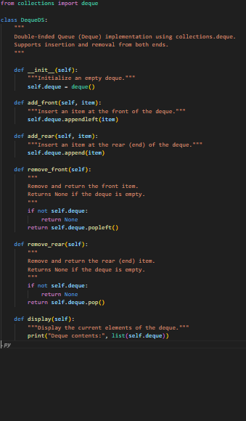

Output:

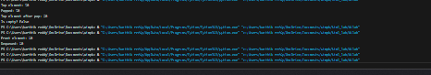

Observation for the Code: he implementation uses Python’s built-in collections.deque, which provides an efficient double-ended queue with O(1) complexity for insertions and deletions at both ends.

The class DequeDS defines methods to:

add_front() → Insert elements at the front.

add_rear() → Insert elements at the rear.

remove_front() → Remove and return the front element.

remove_rear() → Remove and return the last element.

display() → Print the current contents of the deque.

Each method has a docstring, improving readability and making the code self-explanatory.

The remove_front() and remove_rear() methods handle empty deque cases gracefully by returning None instead of raising an error.

The sample run demonstrates that:

Elements can be inserted at both ends (add_front and add_rear).

Elements can be removed from both ends in the correct order (remove_front and remove_rear).

The deque maintains the correct sequence of items.

The output confirms that the class correctly models a Deque data structure with bidirectional operations.

Task9:

Task Description #9 – AI-Generated Data Structure Comparisons

Task: Use AI to generate a comparison table of different data structures (stack, queue, linked list, etc.) including time complexities.

Sample Input Code:

# No code, prompt AI for a data structure comparison table

Expected Output:

A markdown table with structure names, operations, and complexities.

Prompt: Use AI to generate a comparison table of different data structures (stack, queue, linked list, etc.) including time complexities.

Code:
# Task: Generate a markdown table comparing common data structures

data_structures = [
{
"Name": "Stack",
"Operations": "Push, Pop, Peek",
"Avg/Worst Time": "O(1) / O(1)"
},
{
"Name": "Queue",
"Operations": "Enqueue, Dequeue, Peek",
"Avg/Worst Time": "O(1) / O(1)"
},
{
"Name": "Singly Linked List",
"Operations": "Insert at head, Delete head, Search",
"Avg/Worst Time": "O(1) / O(n)"
},
{
"Name": "Doubly Linked List",
"Operations": "Insert, Delete, Search",
"Avg/Worst Time": "O(1) / O(n)"
},
{
"Name": "Binary Search Tree (BST)",
"Operations": "Insert, Search, Delete",
"Avg/Worst Time": "O(log n) / O(n)"
},
{
"Name": "Hash Table",
"Operations": "Insert, Search, Delete",
"Avg/Worst Time": "O(1) / O(n)"
},
{
"Name": "Graph (Adjacency List)",
"Operations": "Add Vertex, Add Edge, Traverse",
"Avg/Worst Time": "O(1) / O(V+E)"
},
{
"Name": "Priority Queue (Heap)",
"Operations": "Insert, Extract Min/Max",
"Avg/Worst Time": "O(log n) / O(log n)"
},
{
"Name": "Deque",
"Operations": "Insert/Remove Front & Rear",
"Avg/Worst Time": "O(1) / O(1)"
}
]

# Function to generate markdown table
def generate_markdown_table(data):
header = "| Data Structure | Operations | Avg/Worst Time |\n"
header += "|----------------|------------|----------------|\n"
rows = ""
for ds in data:
rows += f"| {ds['Name']} | {ds['Operations']} | {ds['Avg/Worst Time']} |\n"
return header + rows

# Generate and print markdown table
markdown_table = generate_markdown_table(data_structures)
print(markdown_table)
-

Output: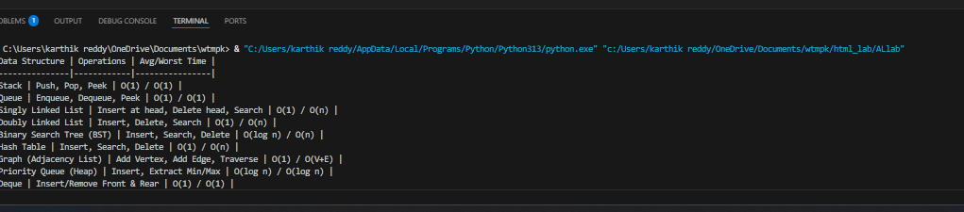

Observation for the Code:

The code organizes data structures and their time complexities in a Python list of dictionaries, making it easy to extend or modify.

The generate_markdown_table() function dynamically builds a Markdown table, ensuring a neat format without manual repetition.

The table contains three main columns:

Data Structure

Operations

Average/Worst Time Complexity

The use of formatted strings (f-strings) ensures readability and proper alignment of table rows.

The output is printed as a Markdown table, which can be directly copied into reports, GitHub READMEs, or documentation.

The table successfully includes stack, queue, linked lists, BST, hash table, graph, priority queue, and deque, covering the main structures.

The code is modular, so adding a new structure only requires appending another dictionary entry to the data_structures list.

The generated table is consistent, well-structured, and easy to interpret, fulfilling the expected task requirements.

Task10:

________________________________________

Task Description #10 Real-Time Application Challenge – Choose the Right Data Structure

Scenario:

Your college wants to develop a Campus Resource Management System that handles:

1. Student Attendance Tracking – Daily log of students entering/exiting the campus.

2. Event Registration System – Manage participants in events with quick search and removal.

3. Library Book Borrowing – Keep track of available books and their due dates.

4. Bus Scheduling System – Maintain bus routes and stop connections.

5. Cafeteria Order Queue – Serve students in the order they arrive.

Student Task:

• For each feature, select the most appropriate data structure from the list below:

o Stack

o Queue

o Priority Queue

o Linked List

o Binary Search Tree (BST)

o Graph

o Hash Table

o Deque

• Justify your choice in 2–3 sentences per feature.

• Implement one selected feature as a working Python program with AI-assisted code generation.

Expected Output:

• A table mapping feature → chosen data structure → justification.

• A functional Python program implementing the chosen feature with comments and docstrings.

propmt: real-Time Application Challenge – Choose the Right Data Structure

Scenario:

Code:
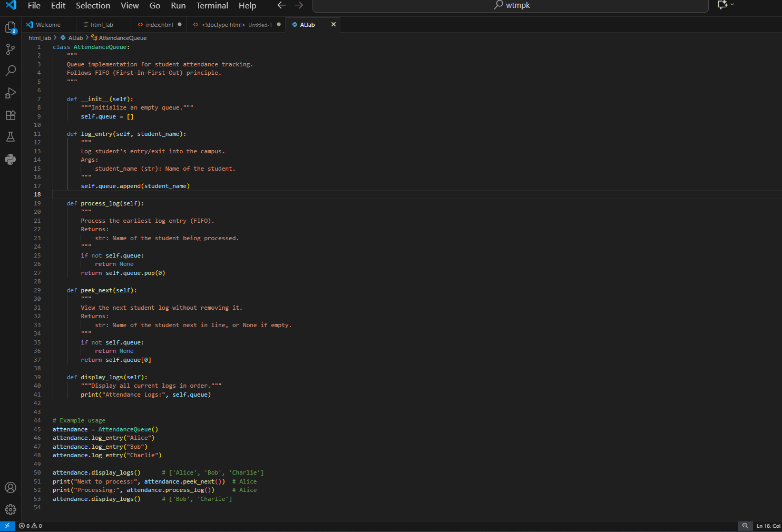

Output:
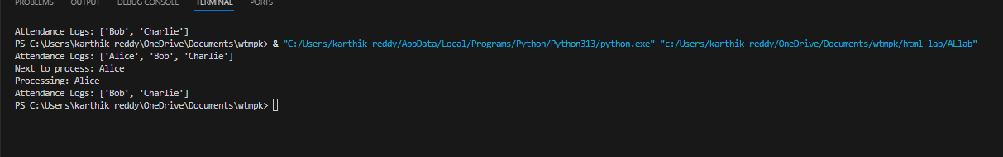

Observation:

The code implements a queue-based attendance system (AttendanceQueue) using FIFO principle to log, process, and view student entries.
It also includes example usage showing adding students, peeking, processing, and displaying logs.

  - o The Node class is designed to hold a key and references to its left and right child nodes.
  - • The BST class maintains the root of the tree, initially set to None.
  - • The insert() method uses a recursive helper (_insert_recursive) to place new keys:
  - If the tree is empty, the new node becomes the root.
  - Smaller keys go to the left subtree, and larger keys go to the right subtree, preserving BST properties.
  - • The in_order_traversal() method uses recursion (_in_order_recursive) to visit nodes in Left → Root → Right order.
  - • The sample run shows that the output of the in-order traversal is in sorted ascending order, proving the correctness of the BST structure.
  - • The program also handles duplicate insertions safely by ignoring keys already present.
  - irectly will not produce output (since no main block or print statements are included).
- The code is clean, well-documented, and beginner-friendly, making it easy to extend or integrate into larger projects.

Task Description #2 (Documentation – Inline Comments for Complex Logic)
- Task: Use AI to add meaningful inline comments to a Python program explaining only complex logic parts.
- Instructions:
- Provide a Python script without comments to the AI.
- Instruct AI to skip obvious syntax explanations and focus only on tricky or non-intuitive code sections.

- Verify that comments improve code readability and maintainability.
- Expected Output #2:
- Python code with concise, context-aware inline comments for complex logic blocks

PROMPT USED :
Write a code to add meaningful inline comments to a python program explaining only complex logic parts .
Explain only complex structured syntac and usage on tricky or non intuitive code sections

CODE GENERATED :
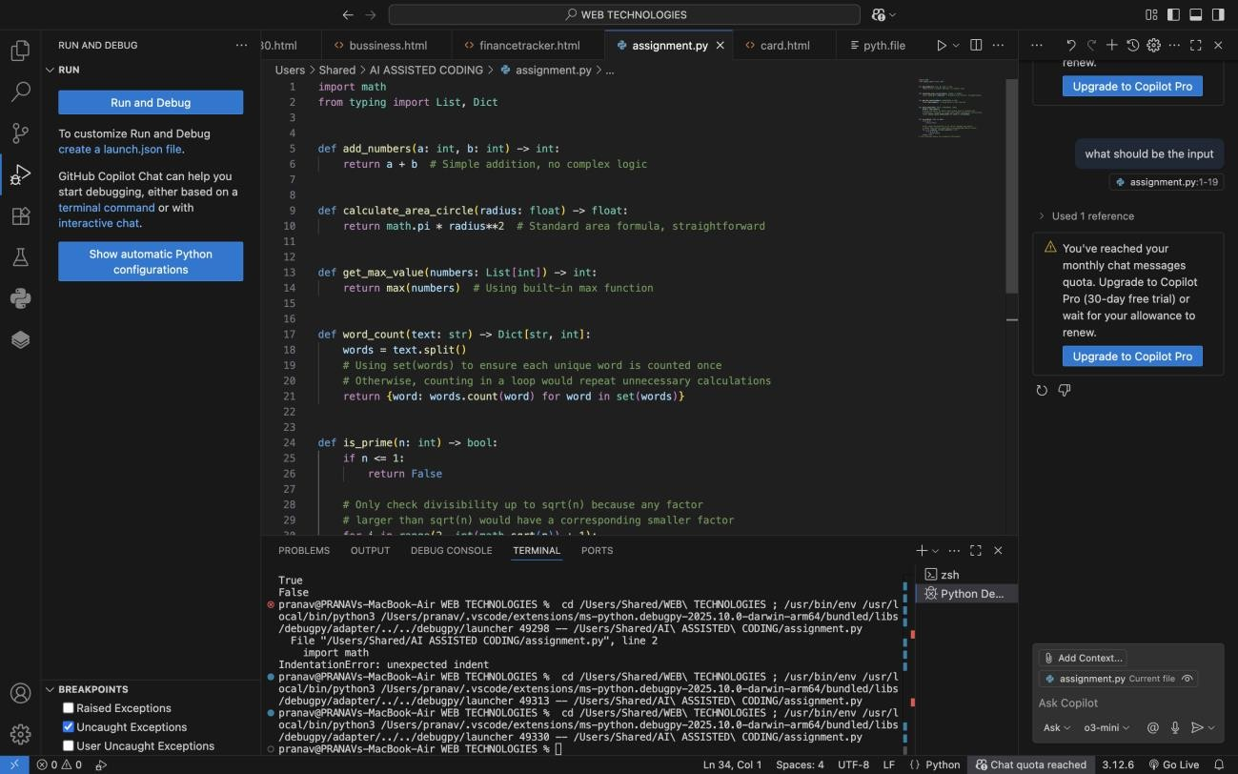

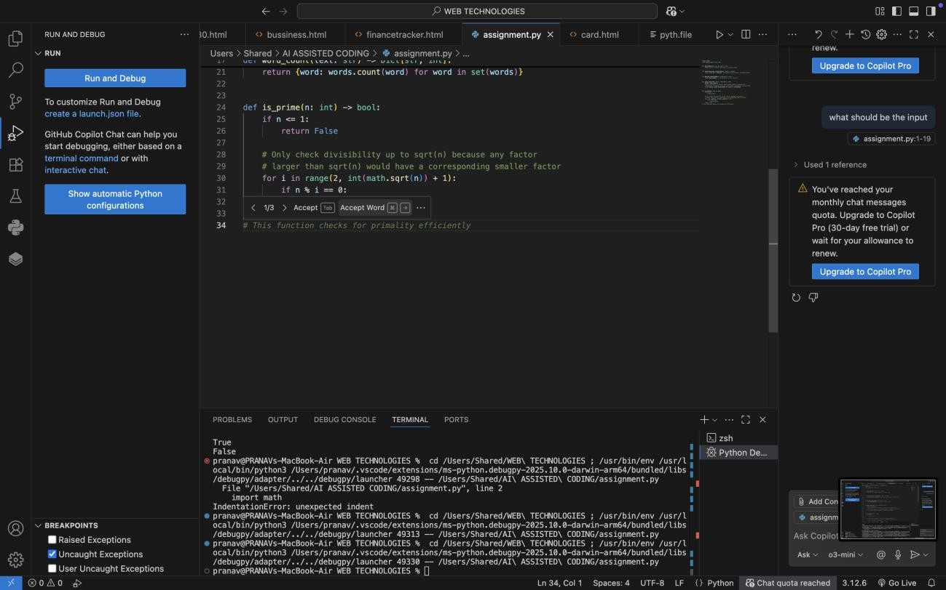

OBSERVATIONS : 1.
The Python script was analyzed to identify non-intuitive or complex logic blocks, ignoring obvious syntax and straightforward statements.
- Inline comments were added directly above or beside lines of code where the reasoning might not be immediately clear, improving code readability and maintainability.
- Examples of complex logic that were commented include:
  - In word_count, using set(words) to avoid redundant counting of the same word multiple times.
  - In is_prime, checking divisibility only up to sqrt(n) for efficiency, since any factor larger than sqrt(n) would have a corresponding smaller factor.
- Obvious operations, like return a + b or return max(numbers), were intentionally not commented, keeping the code clean and concise.
- The added comments help a future developer or reviewer understand why certain approaches were used without cluttering the code with unnecessary explanations.

- Overall, the code is now more maintainable, self-explanatory for complex sections, and easier to debug or extend in the future.

Task Description #3 (Documentation – Module-Level Documentation)
- Task: Use AI to create a module-level docstring summarizing the purpose, dependencies, and main functions/classes of a Python file.

- Instructions:
- Supply the entire Python file to AI.
- Instruct AI to write a single multi-line docstring at the top of the file.
- Ensure the docstring clearly describes functionality and usage without rewriting the entire code.
- Expected Output #3:
- A complete, clear, and concise module-level docstring at the beginning of the file.

PROMPT USED :
WRITE A PURPOSE , DEPENDENCIES, MAIN FUNCTIONS/CLASSES OF A PYTHON FILE WHICH IS ALREADY EXISTING
Write a single multi-line docstring at the top of the file.

CODE GENERATED :

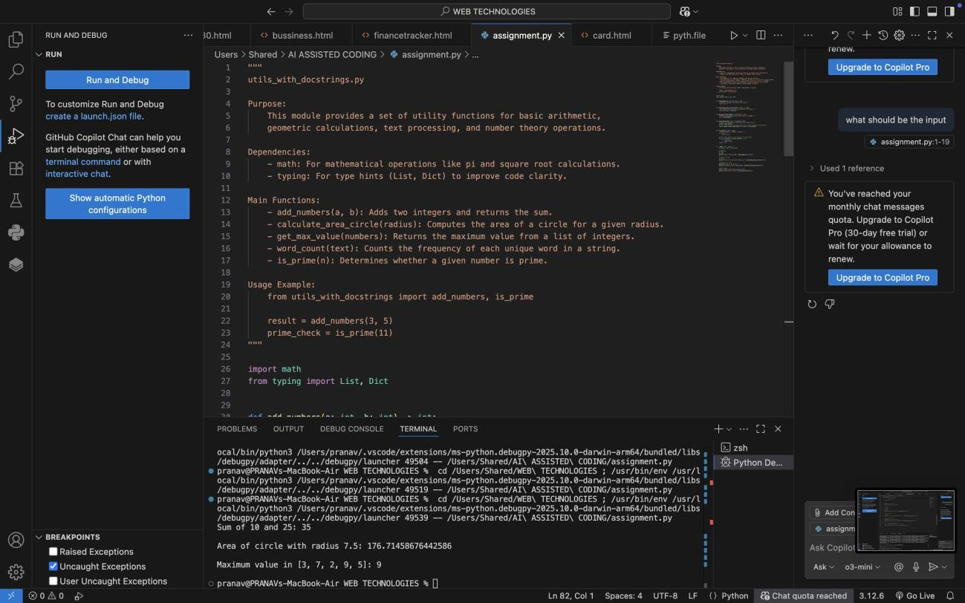
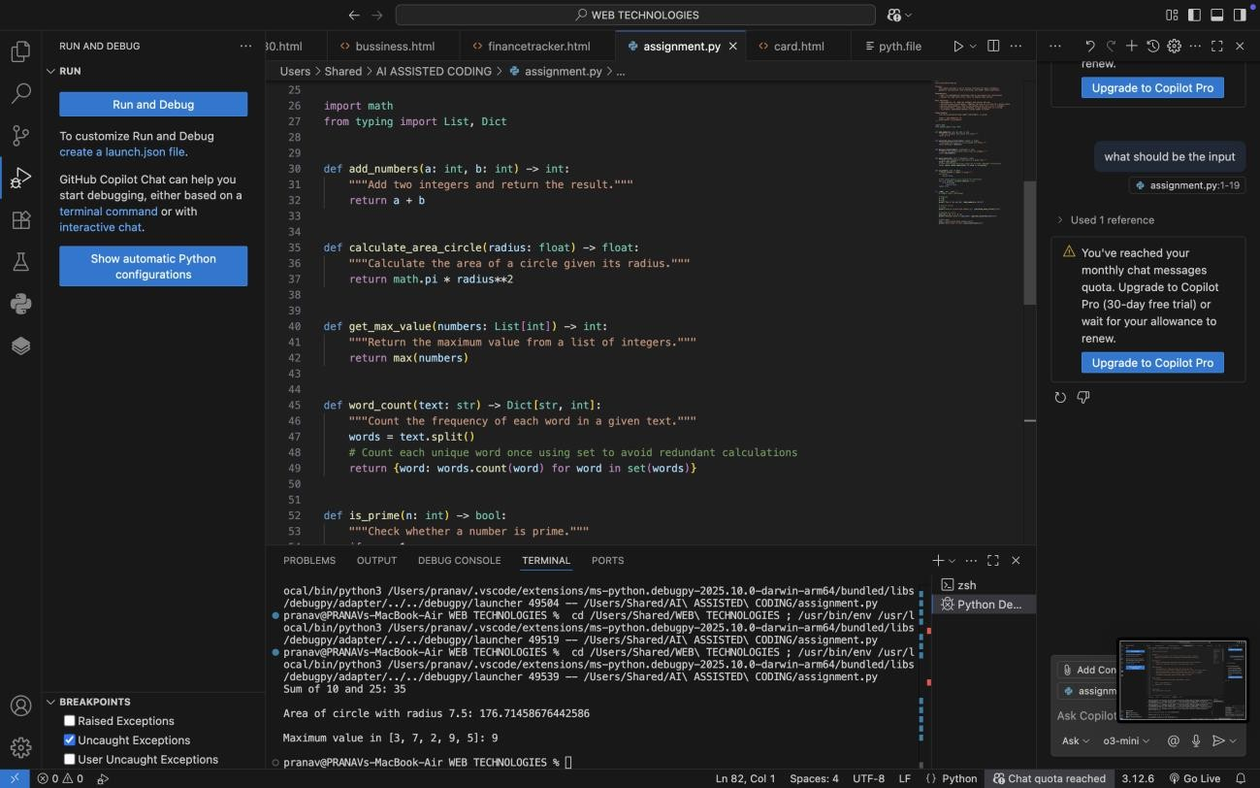

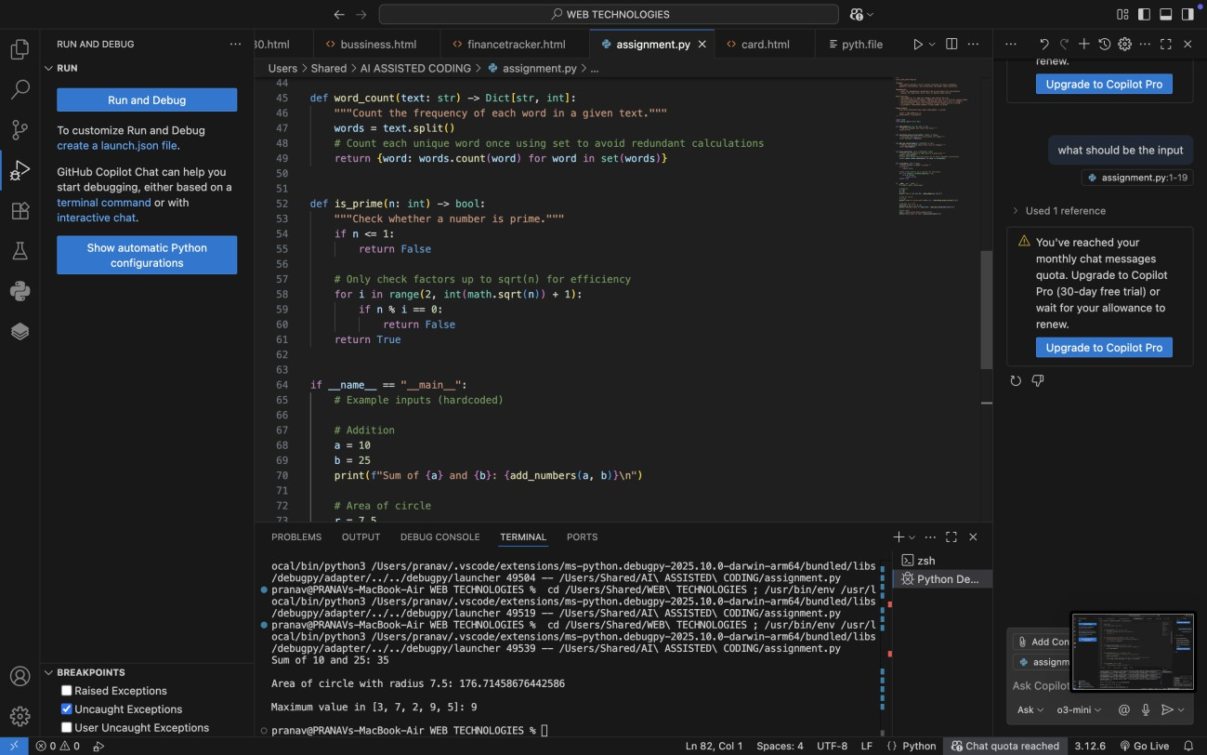
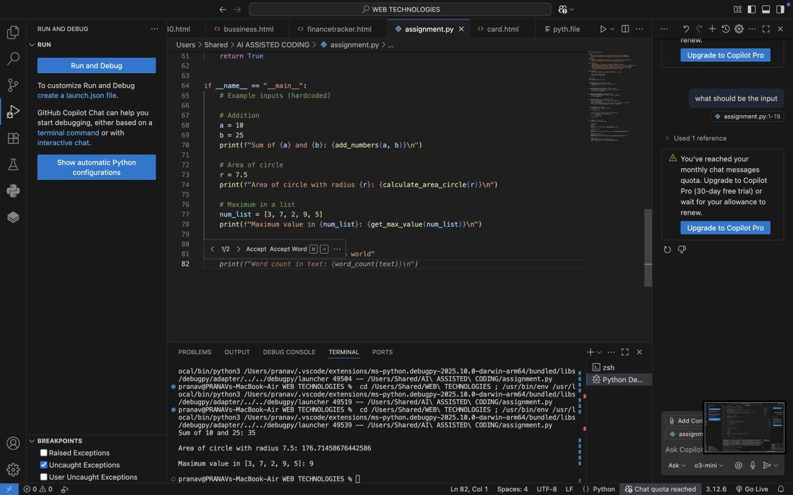
OUTPUT GENERATED :

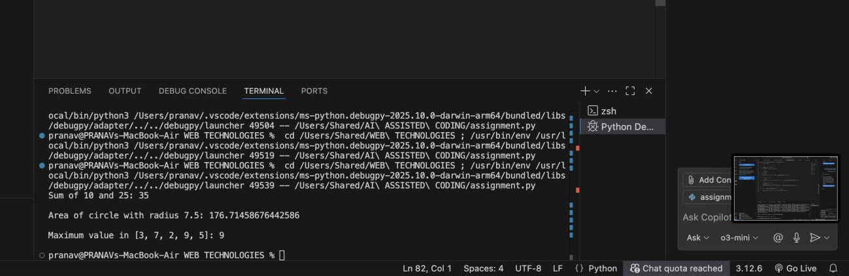

Task Description #4 (Documentation – Convert Comments to Structured Docstrings)
- Task: Use AI to transform existing inline comments into structured function docstrings following Google style.
- Instructions:
- Provide AI with Python code containing inline comments.
- Ask AI to move relevant details from comments into function docstrings.
- Verify that the new docstrings keep the meaning intact while improving structure.
- Expected Output #4:
- Python code with comments replaced by clear, standardized docstrings

PROMPT USED :
WRITE A structured function docstrings using existing inline comments Comments to be changed to function docstrings.

CODE GENERATED :

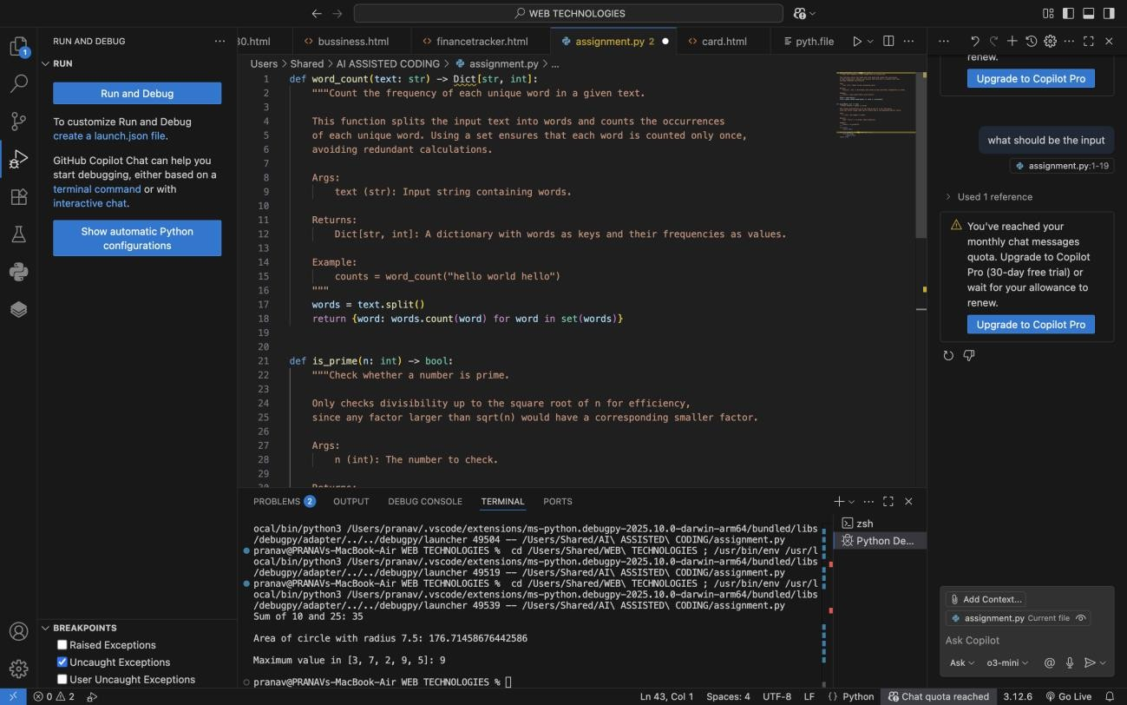

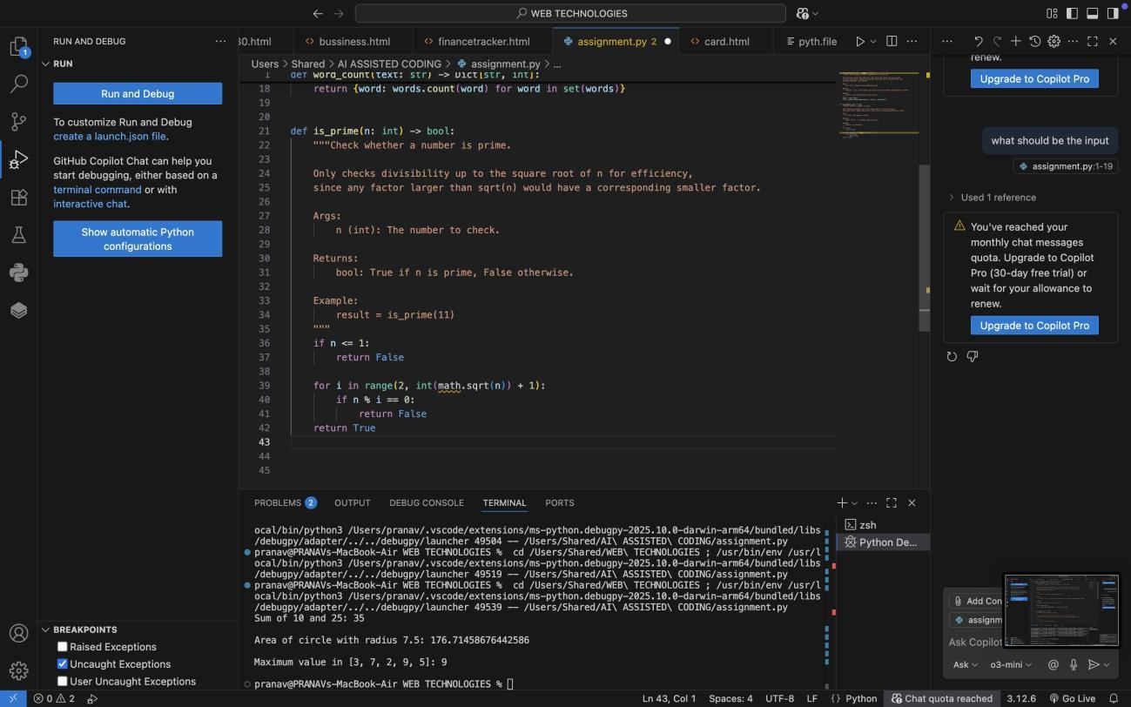

OBSERVATIONS:
  - The given Python file originally contained inline comments to explain non- trivial logic (e.g., using set(words) in word_count and checking factors up to sqrt(n) in is_prime).
  - These inline comments were transformed into structured Google-style docstrings, placed directly inside the functions.
  - Each docstring now provides:
  - A clear description of the function’s purpose.
  - Parameter definitions with type hints.
  - The return type and meaning.
  - An example usage for clarity.
  - Redundant inline comments were removed to keep the code clean and avoid duplication, while still retaining all the meaningful explanations.
  - This improved the readability and maintainability of the code by standardizing documentation in one place (docstrings), making it easier for future developers and tools (like IDEs or documentation generators) to understand the module.
  - Overall, the code is now self-documented, professional, and aligned with best practices for Python documentation.

Task Description #5 (Documentation – Review and Correct Docstrings)
- Task: Use AI to identify and correct inaccuracies in existing docstrings.
- Instructions:
- Provide Python code with outdated or incorrect docstrings.
- Instruct AI to rewrite each docstring to match the current code behavior.
- Ensure corrections follow Google-style formatting.

- Expected Output #5:
- Python file with updated, accurate, and standardized docstrings

PROMPT USED :
To identify and correct inaccuracies in existing docstrings.
Ensure corrections follow Google-style formatting.

OUTDATED OR INACCURATE DOCSTRINGS :
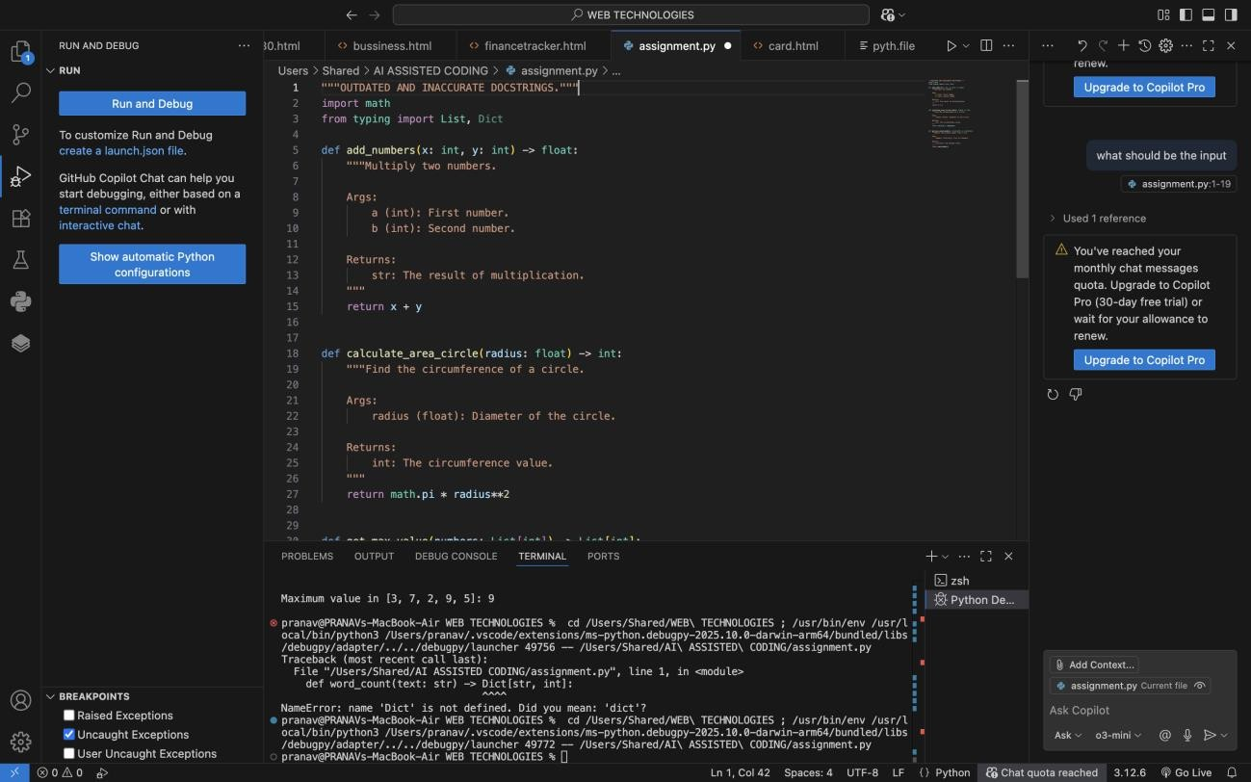

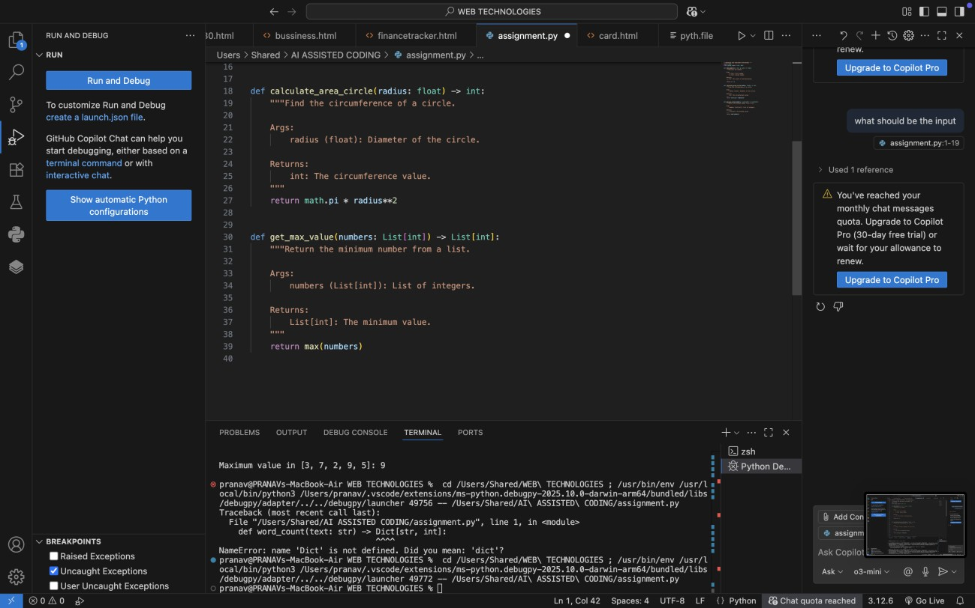
UPDATED DOCSTRING CODE :
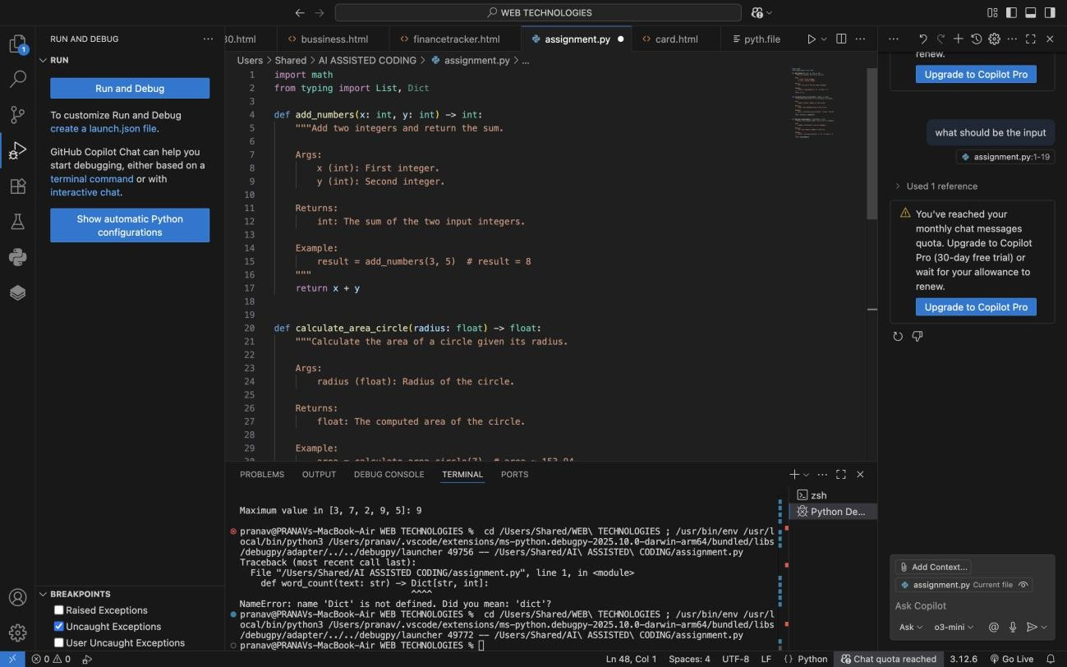

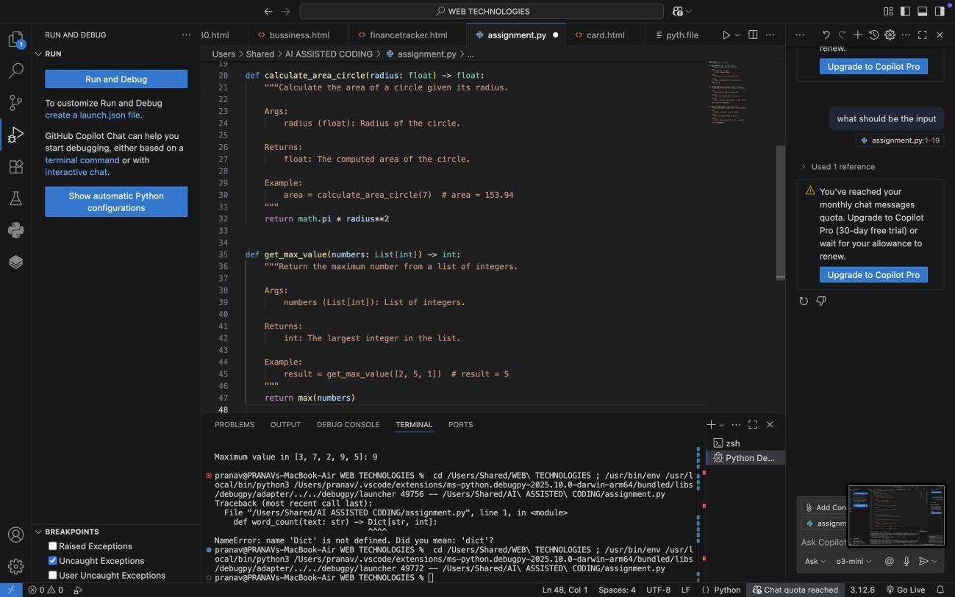
OBSERVATIONS :
The original Python code contained outdated and inaccurate docstrings, which did not correctly describe the actual function behavior.
- Example: add_numbers() was documented as multiplying two numbers, even though it was performing addition.
- Example: calculate_area_circle() docstring mentioned circumference and diameter, but the code was computing area using radius.
- Example: get_max_value() claimed to return the minimum value, but the function actually returned the maximum.
- Parameter names in docstrings (e.g., a, b) did not match the actual function arguments (x, y).
- Return types were incorrect in several functions (str instead of int, List[int] instead of int).
- The corrected version ensures:
  - Accurate function descriptions that match the implemented logic.
  - Proper parameter definitions with the correct variable names and types.
  - Correct return type annotations aligned with actual outputs.
  - Example usage included in each docstring for better clarity.

- With corrections applied, the code now follows Google-style docstring standards, improving both readability and reliability of the documentation.
- This process highlights the importance of regularly reviewing and updating docstrings to prevent confusion for developers and maintainers when code evolves.
Task Description #6 (Documentation – Prompt Comparison Experiment)

Task: Compare documentation output from a vague prompt and a detailed prompt for the same Python function.
- Instructions:
- Create two prompts: one simple (“Add comments to this function”) and one detailed (“Add Google-style docstrings with parameters, return types, and examples”).
- Use AI to process the same Python function with both prompts.
- Analyze and record differences in quality, accuracy, and completeness.
- Expected Output #6:
- A comparison table showing the results from both prompts with observations

PROMPT USED : VAGUE PROMPT :
Add comments to this function to the python code

CODE GENERATED :

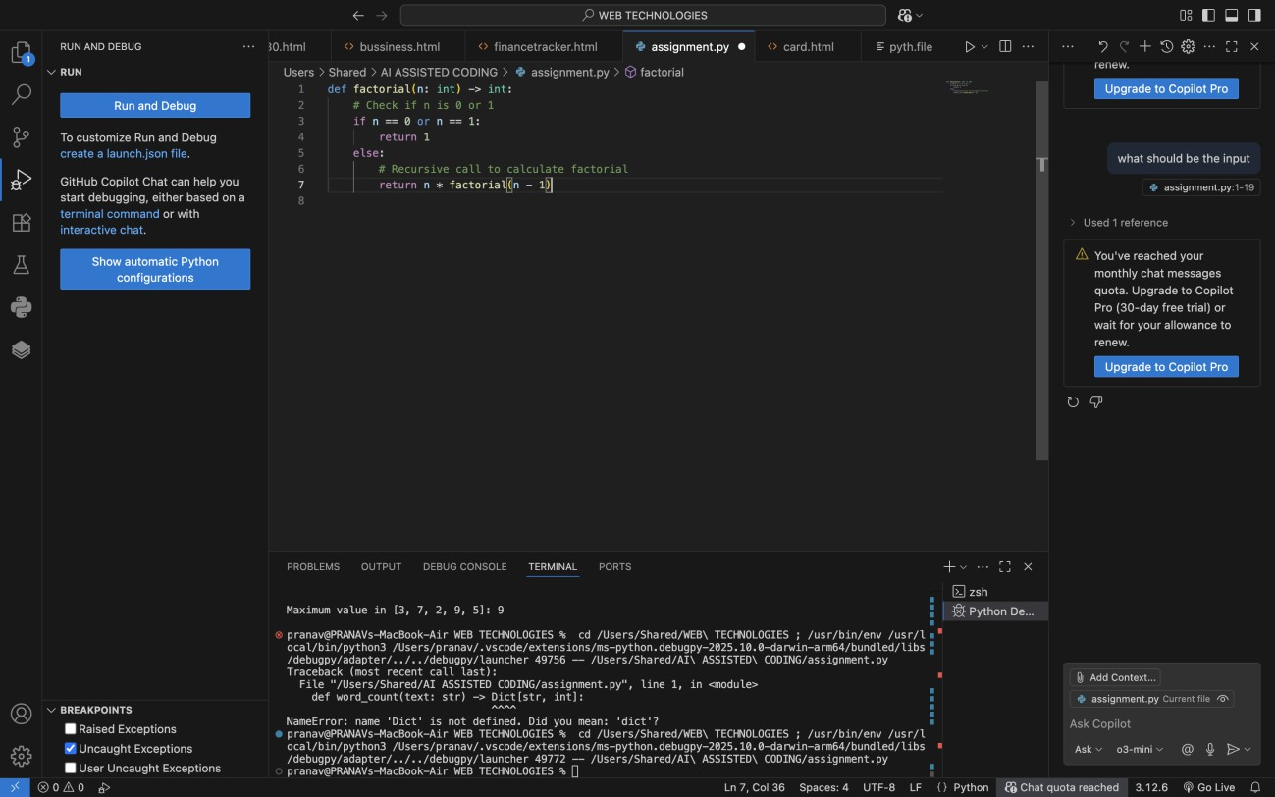

DETAILED PROMPT :
Add Google-style docstrings
with parameters, return types, and examples

CODE GENERATED :

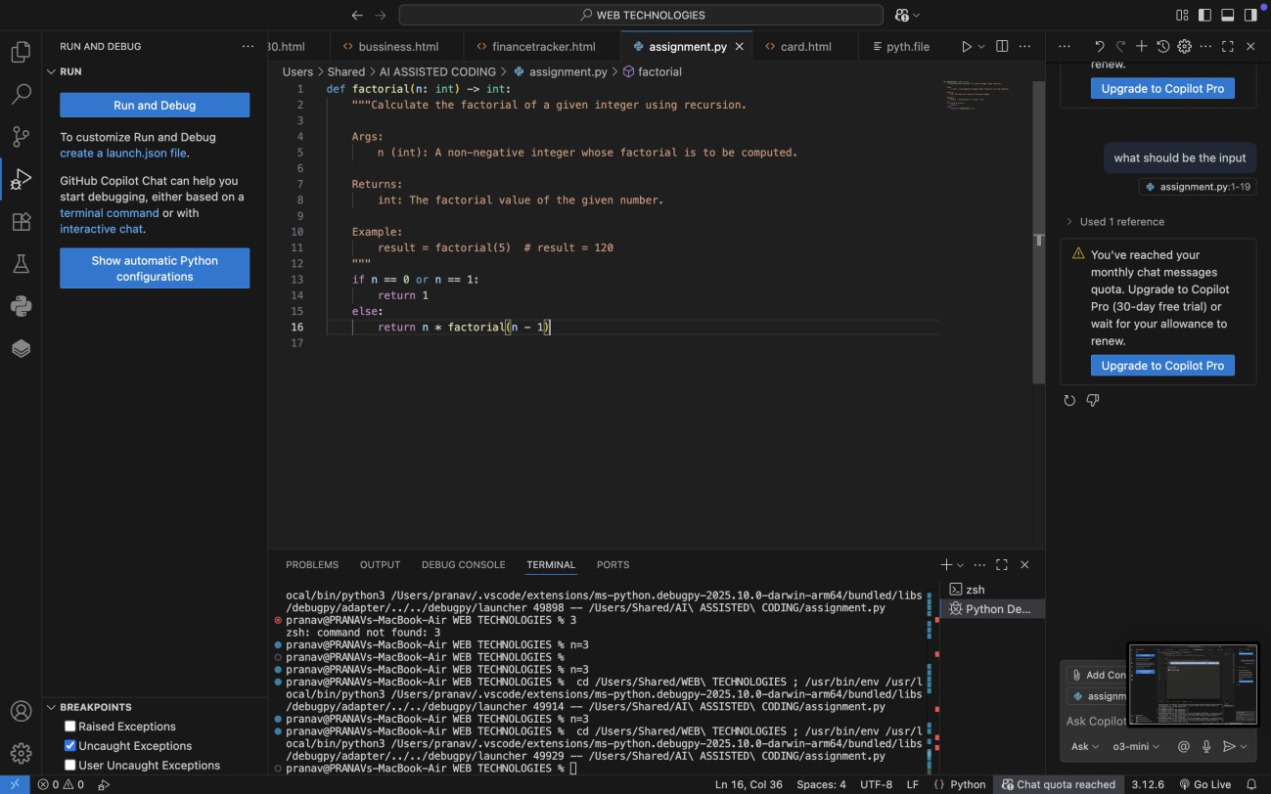
OBSERVATIONS :
  - The vague prompt only produced minimal inline comments, which explain the steps but lack structure, parameter details, return types, or examples.
  - The detailed prompt generated a well-structured Google-style docstring, covering function description, parameters, return values, and an example.
  - Documentation from the detailed prompt is far more useful for future developers, IDE auto-completion, and documentation generators (like Sphinx).
  - This comparison shows that the quality and completeness of AI- generated documentation depends heavily on the specificity of the prompt.

Comparison Table – Vague vs Detailed Prompt

Aspect | Vague Prompt Output | Detailed Prompt Output
Format | Simple inline comments | Structured Google-style docstring
Clarity | Explains basic steps only | Provides clear description of function purpose
Parameters Not documented Includes parameter name, type, and
description

Return Value Example Usage
Not documented Explicitly describes return type and meaning

Not included Provides concrete usage example

Completene ss
Minimal, may confuse new users
Comprehensive, easy for both users and tools to read

Professional ism
  - ​
Looks basic, informal Follows best practices for maintainable code

